**HND Computer Games Development**

**Graded Unit 2**

**Evaluation Stage**

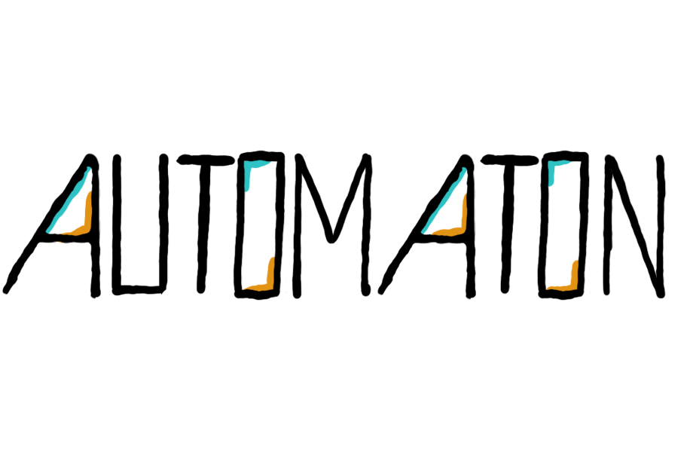

Evaluation Document

Contents

Outline of the Assignment 3

Evaluation of the Final Solution 3

Strengths and Weaknesses of the Final Solution 4

Improvements to the Project and Process 5

Self-Evaluation as the Developer 6

# Outline of the Assignment

The project I undertook was a 3D puzzle and platformer game with themes of Science Fiction, Adventure and Mystery. As laid out in the original brief, ‘Automaton,’ would follow the protagonist Delta – an artificial intelligence who was built by a group of scientists to replace the need for humans in dangerous experiments – and his journey aboard the SRS Kronos, a space station based in the Andromeda galaxy. Delta would awake on the station at the beginning of the game with no memory of his previous life, and encounter Sigma, a cleaning robot under the servitude of a leading biomedical scientist aboard the station. Sigma would inform him that he was involved in a time travel experiment that appears to have gone wrong, as everyone from the station including other robots have now vanished. Delta and Sigma must now journey through the only unlocked portion of the station, solving puzzles and maneuvering platforms to uncover the mystery of the SRS Kronos.

Gameplay would consist of solving puzzles by retrieving a set number of objects known as energy cubes from around the room and using them to unlock the door to the next puzzle room. Movement would be restricted to using a grappling hook attached to the player’s hand to swing from one platform to another, as they would be too spaced out to jump. In the original brief, the player would also have multiple tools that they could swap out for the grappling hook and perform other tasks, depending on the specific puzzle. These grappling bars could be double sided, meaning the player could move back and forth across them at will, or single sided, meaning they could cross over one way but not return. This would add additional challenge, as movements would have to be carefully thought out and planned before they were made. Energy cubes would also often be initially locked behind orange doors that could only be unlocked by having a bomb cube thrown at them, something the player would have to take into consideration and search for first. The player would also only be able to carry one object at a time with them, creating further challenge. The player would be able to talk to Sigma in each puzzle room and ask him for hints if they were stuck, or alternatively ask him lore-related questions and learn more about the game’s narrative. The narrative would be fed to the player gradually in small pieces through each room, in the form of dialogue with Sigma as well as collectable notepad items that contained messages exchanged between the station’s scientists in the weeks leading up to the experiment.

The game would feature multiple customization and accessibility settings, including but not limited to rebinding keys, resolution and graphics settings, and audio management. It would also feature an extensive saving and loading system, that would allow the player to save their progress in a specific memory slot and load it up again from a menu at any point.

The project would take place over a period of approximately five months, with time allocated for modelling, rigging, animating, scripting, research, and design respectively, and follow an agile methodology.

# Evaluation of the Final Solution

Overall, the final version of the game meets the original brief accurately. There were a couple of significant changes made to the project scope rather early on in development to compensate for time and resources, however the overall structure of the game remains the same.

Upon beginning development, I realized my initial design for the puzzles and Delta’s multi-tool hand was too complex and would be very difficult to design levels for with reusable assets, so the multi-tool idea was scrapped and replaced with just the grappling hook as the right hand, and a suction cup-like tool in the left hand for picking up objects. I also did not have a clear idea of how many puzzles I wanted the game to have or the exact structure of how the narrative was going to be delivered to the player. I initially overestimated how much time I would have to design and build levels, and was considering implementing seven to ten puzzle rooms, however I realized about halfway through the development process that designing such a large quantity of rooms that were both fun and challenging would be too time consuming and difficult. I eventually settled on three main puzzle rooms, complemented by a small tutorial and end room to introduce and then bring the narrative to a close, respectively. These two changes combined meant I had greater flexibility with my time and only needed to create a small number of assets that could be used repeatedly. Additionally, I could build the levels much more quickly as they would all follow similar structures and mechanics.

The overarching narrative is the same, except for certain details. I initially had written the character Sigma to be very benevolent and a genuinely helpful and caring character towards the player. Towards the end of development, I decided to rework his character slightly as the game’s full plot started coming together, as I did not have a set plan of how the game would end during the planning stage. Sigma’s character eventually became something with a more sinister side as I thought this would make for a more interesting plot, as it’s implied through the collectable notepads that he is the one that sabotaged the player just before the beginning of the game.

The most significant change made from the original plan is the complete absence of the saving and loading system. After all other customization features were implemented I began work on the saving system, however this proved to be too time consuming and fiddly to implement at such a late stage in development and was thus scrapped to make more time to focus on polishing and finalizing other aspects of the gameplay.

Despite these alterations, the general structure of the game remains the same as the initial plan, with only a handful of changes made in the details.

# Strengths and Weaknesses of the Final Solution

The final product has many strengths, but it also has features that could be improved. The visuals and monochrome colour scheme reflect the setting of a space station well, and does an effective job of immersing the player in a futuristic space setting. The ambient and mechanical audio also assists with this, and I believe was well suited to the game’s science fiction and mystery themes. The low-poly art style combined with the use of a range of solid colours is aesthetically pleasing, and gives the game an animated, cartoonish feel, which was the desired effect.

The main mechanic of the grappling hook makes for intriguing and challenging gameplay, and has overall been effectively implemented. However, it does have flaws and did cause some minor problems, especially during user testing. When initially grappling, the player is pushed forward towards the centre of the bar before resuming swinging back and forth normally. This appears like the player is teleporting, and can be jarring at first, breaking the flow of gameplay for a moment. Additionally, as seen during user testing, it can be very difficult to grapple from one bar to another seamlessly. In practice, the hit boxes for the bars appear to be too small for some, leaving a very short window of opportunity for the player to successfully fire the grappling hook. This is meant to be challenging and require the player to time their movements, so some difficulty is expected. However, the current level of difficulty can easily lead to players becoming increasingly frustrated with the game and enjoy it less as a result, especially if they don’t have particularly fast reflexes. Thus, this can make the game less effective in providing an enjoyable experience to the player.

Each of the puzzle rooms is effective in causing the player to think and plan their movements carefully, and each puzzle is always more challenging than the previous one. This serves to slowly introduce the player to the game’s mechanics without overwhelming them with too much at once. However, I do believe there is a significantly larger jump in difficulty from level one to level two, and this can be more difficult for the player to adjust to than the jump from level two to three.

The dialogue system is one of the game’s most interesting features, and serves as a way of delivering the narrative to the player without forcing it upon them, as Sigma can be completely ignored past the tutorial if the player is not interested in story and prefers a more hands-on gameplay experience. The collectable notepads also fall under this category, and serve as another form of optional lore to flesh out the world and backstory of Automaton. This is one of the game’s main strengths, as it allows a degree of player freedom and choice, and proved to be an effective design decision in practice as about half of user testers chose to ignore the storyline and just play the game. Despite this, there are minor flaws with both. The same function to create the scrolling text was used for both, and it is visually pleasing as it gives the illusion of being printed on a typewriter, however it doesn’t always print correctly. A new line will be taken when it reaches a maximum number of characters by inserting a hyphen between words and continuing on the line below, however it doesn’t always do this appropriately, especially with the notepad text. Sometimes it will take a new line or insert a hyphen unnecessarily, and this can cause some readability issues for players, as the sentence starts to look jumbled. However, this is not a very major issue, and testers appeared to be able to read the text without too much of a problem.

Overall and despite flaws, the final version of the game has a sizeable number of strengths to outweigh its weaknesses, and is an accurate representation of the original design.

# Improvements to the Project and Process

Overall the development process went smoothly, as the final product accurately represents the initial plan. However, there are features that could be improved if the game were to be developed further, or if the project were redone.

I would first try and have a more established plan of how I want each level to play out, and have a clear beginning and end for the narrative before beginning physical development. This would allow a better structure for constructing the game as I did not have clear level designs for the entire game until halfway through development, which slowed me down slightly. I would also try and implement my models and other assets into the game as soon as I could, as this was not something I did until later on and used placeholders for a large portion of development. I did this initially because I wanted to focus on programming and have the main mechanics set up before I began creating and implementing art assets, as that was my priority due to my lack of experience in Unity. However, this caused some delays, as when the models were finally implemented, it sometimes changed how my scripts worked. This was especially so for my custom player controller, where when I attached it to my new model, the collisions became nonexistent. I then had to spend several days figuring out and then correcting these issues, which I wouldn’t have had to do if I had written these scripts with my key models already in place.

If this game were to be taken further, there are a few features I would have implemented, given the time. My primary goal would be to finish implementing the saving and loading system, as I’d already done a significant amount of work on it before deciding to leave it out of the final build. This improves the game’s functionality and allows the player to play at their own pace without worrying about having to restart from the beginning after closing the program. I would also design and add a handful more levels so that progression feels more natural and the difficulty jump isn’t as noticeable as it currently is, as well as giving the game more content. Finally, I would tweak the grappling mechanic to feel smoother and not like the player is partially teleporting, as well as make it slightly easier to hook onto bars.

# Self-Evaluation as the Developer

During the development process, I think I performed as well as I possibly could. However, I am far from an expert in all fields and thus some challenges were presented to me over the course of the project that required careful prioritizing.

I believe my biggest strength during this project was my programming ability, as I was eventually able to design and implement mechanics that I wasn’t completely certain I would be able to, at first. I had spent much time practicing object-oriented programming techniques in anticipation of the project, and I believe it paid off. However, I struggled at first to come to grips with how Unity interprets C#, as I had never used the language nor the engine before last December. To compensate, I spent a significant portion of my time reading about Unity’s built in functions and how to use them so that I could design my scripts more effectively. Overall, I’m very pleased with how the game turned out in terms of programming implementation, although I will admit some areas of the programming aren’t very well optimized in terms of memory management. This is something I seek to improve in the future, as I would like to learn how to design software that is both effective and efficient, as well as improve my overall programming ability. Additionally, I learned a lot about working with Unity during the course of the project as well as scripting in C#, and this is something I intend to carry with me through university and beyond.

Any artistic ability I have, although I didn’t use it very much for this project, was also useful and a significant strength. I deliberately chose a low-poly, cartoonish art style so that I wouldn’t have to spend too much time creating models, as I’m not entirely confident in my modelling ability. However, the ones I produced I believe are aesthetically pleasing, and convey a specific artistic style.

Despite all this, there were areas that I definitely struggled with. I have no experience or knowledge of audio creation or management, however at the beginning of development I had planned to try and create my own sound effects. Although around halfway through the project timescale, I began to realize I did not have the time, resources, or knowledge to attempt this, and decided to outsource all of my audio. Audio creation is something I would’ve liked to learn how to do given more time, and a skill that I want to develop for future projects. I also felt I struggled a lot with design. I realized after choosing to build a puzzle game that a large chunk of the player’s enjoyment comes from the design of the level. A poorly designed level would cause confusion and be uninteresting, detrimental to a puzzle game. This was something I spent a considerable amount of time on and I found rather challenging, as designing the layout of a level and ensuring it is both practical and fun is not something I’m very experienced with, and I find very mentally taxing. I also spent some time thinking about how to balance the game’s difficulty and ensure that progress through the levels felt natural, which took a fair amount of work. Overall, I found the design process very mentally exhausting at times, and I would say this was the most challenging aspect of development and a weakness of mine. This is something I would like to improve in the future, especially for personal projects.

There were also some unforeseen events that occurred during development. On many occasions, the college had strike days during classes, which meant that many lecturers were unavailable for a time. More severely, for the majority of the semester we did not have all of the tools we needed to work in class. Not every classroom we visited had the software we needed installed, sometimes even when we needed it for that class, meaning some time was lost that could’ve been spent working on the project. Frequently the Unity plugin for Visual Studio would be uninstalled, leaving programming near impossible if you had not memorized the entire Unity API. Additionally, towards the end of development, Unity was reverted to a years-old and severely out of date version that corrupted any newer file that you tried to open it with. At this point, these tools made being productive in the college completely impossible. I was left feeling extremely disappointed and mistrustful of the lack of reliable resources provided, and needed an alternative. To get around this, I did the majority of the developmental work for Automaton at home on my own computer and only used college computers when I absolutely had to, as I could ensure I would always have stable versions of all the software I needed to complete the project. This proved an effective strategy, and I was able to complete the game to a high enough standard as I had originally intended.

Overall, I believe I performed very well and had an effective development process, despite hiccups with certain resources and skills. I worked hard on what I knew and either improved or found a way around my weak points without them impacting the quality of the final product too much. Any of my weaker skills I seek to improve for future projects, as well as continue to build on my strengths, and I can confidently say that I am happy with the end result.